|  |  |  |  |  |  |
| --- | --- | --- | --- | --- | --- |
| **Validation** | | | | | |
| Author | | **Controller** | | **Approver** | |
| Name | Date/Visa | **Name** | **Date/Visa** | **Name** | **Date/Visa** |
|  |  |  |  |  |  |

Document History

|  |  |  |
| --- | --- | --- |
| Version | Date | Version Details |
|  |  |  |
|  |  |  |
|  |  |  |
|  |  |  |
|  |  |  |

Participants

|  |  |  |  |  |
| --- | --- | --- | --- | --- |
| Company | Name | ID | Role | Present |
|  |  |  |  |  |
| ThoughtWorks | Rafael S Almeida |  | Solution Architect | Tech Leader | O |
|  |  |  |  |  |
|  |  |  |  |  |
|  |  |  |  |  |
|  |  |  |  |  |
|  |  |  |  |  |
|  |  |  |  |  |
|  |  |  |  |  |
|  |  |  |  |  |
|  |  |  |  |  |
|  |  |  |  |  |
|  |  |  |  |  |
|  |  |  |  |  |
|  |  |  |  |  |
|  |  |  |  |  |
|  |  |  |  |  |
|  |  |  |  |  |

1. Objective

The objective of this document to bring a vision about the develop environment for this application TW-Merchant-Galaxy-Changelle and server as a reference to change in the future.

1. Introduction

For developing the application we need to choose the stack of technology that we will use and build the application

1. Desing Architecuture

To build this application we will use some of the technologies and tools in order to provide the common environment for another developer

* Platform java 8+
* Maven
* Junit 4.12
* Git Version Control

4. Downloading the Project Source

You can get the source code from the Git repository in the following URL:

<https://github.com/rafaelinformat/merchant-galaxy-challenge.git>

Also you can enter in the folder project that was submitted.

5. Build the Project

{DIR_PROJET} $ **mvn install package**

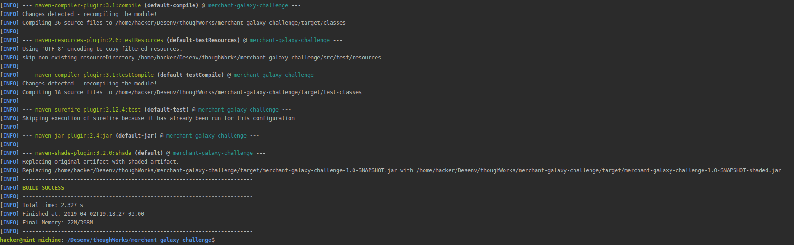

6.Buid the Project with Tests and without Tests

{DIR_PROJET} $ **mvn install -DskipTests=false**

{DIR_PROJET} $ **mvn install -DskipTests=true**

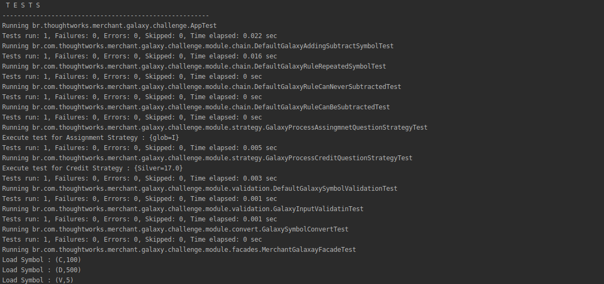

7. Execute a specific test

**$ mvn -Dtest=GalaxyProcessAssingmnetQuestionStrategyTest test**

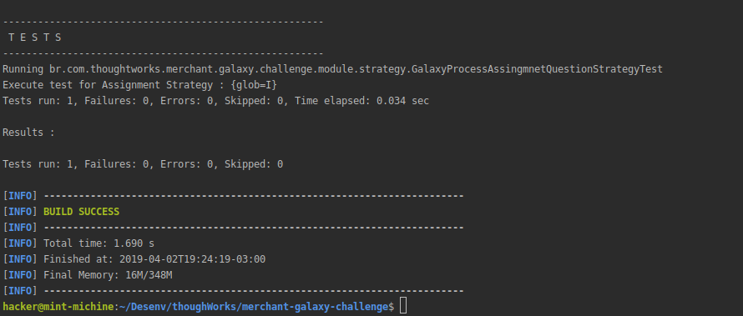

Ne pas supprimer ce saut de section >>>